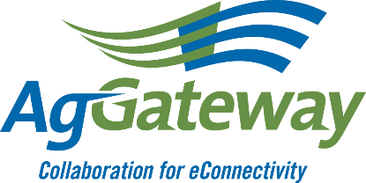
2023 Ron Storms Leadership Award
Nomination Form

Deadline for submission is October 10, 2023

This award recognizes outstanding volunteer leadership achievement in promoting and enabling the transition to digital agriculture. This leadership award is given annually to a member (volunteer, not staff) of AgGateway, and is awarded at the Annual Conference. Candidates demonstrate:
- Dedication to the mission to promote and enable the industry’s transition to digital agriculture.
- Leadership in moving goals and activities forward, i.e., achieving progress.
- Ability to promote collaboration among AgGateway teams.
- Participation in AgGateway leadership (which may include board, steering committees, working groups, task forces, committees, etc.) for at least 2 years.
- Active participation and leadership in at least 2 different activities (e.g., project participation, working group or committee leadership, task force participation, etc.)
- Candidate’s company must be an AgGateway member at the time of nomination.

Please fill out this nomination form; an additional page can be added if needed. You may also respond to these questions in the body of an email (Subject: “Ron Storms”) and submit to Member Services at Member.Services@AgGateway.org.

1. Your name, company, title, phone and email

2. Name of the nominee, company and title

3. How long has the nominee been involved with AgGateway? (To the best of your knowledge)

4. What activities has the nominee been involved with at AgGateway?

5. How has the candidate helped promote and enable the industry’s transition to digital agriculture?

6. How has the candidate demonstrated leadership? Fostered collaboration? Demonstrated problem-solving to move eConnectivity forward?

7. Please include one additional reference (name, company, phone and/or email address).

Thank you for taking the time to let us know a little about the nominee. Please submit this form
or put the contents in an email to Member.Services@AgGateway.org by October 10, 2023.

